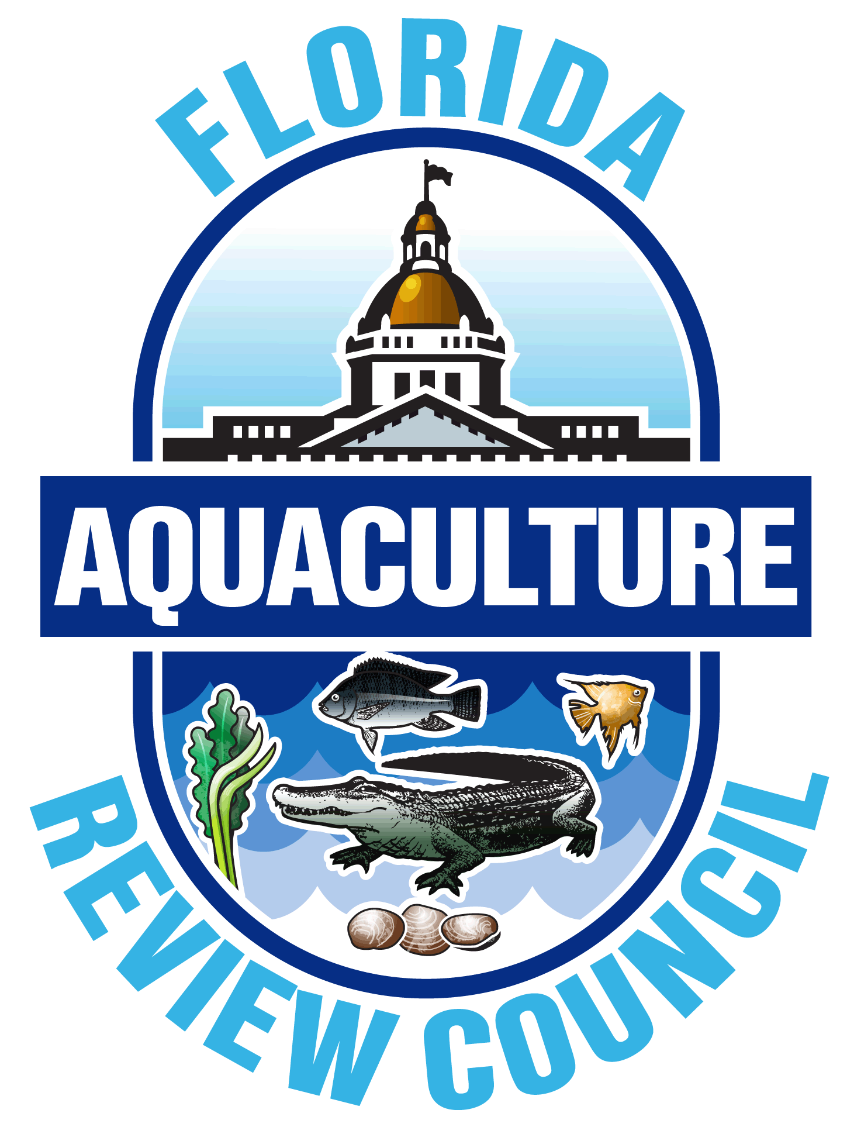
Announcement FY 2023-24

Florida Aquaculture Review Council
Call for Statements of Interest

The Aquaculture Review Council, an advisory council to the Commissioner of Agriculture, is pleased to announce a call for Statements of Interest to perform applied aquaculture research and economic development projects during the State of Florida 2023-24 fiscal year (July 1, 2023 to June 30, 2024).

The Council is focused on stimulating the growth and development of aquaculture in Florida. As the solicitation for statements is intended to create a partnership between the public sector (universities, non-profits, State and Federal agencies) and the commercial aquaculture industry, projects must address applied research and economic development priorities and transfer all results directly to Florida aquaculturists. This package contains all necessary information and instructions for preparing a Statement of Interest.

I. Submission
Applicants are strongly advised to pay close attention to all submission details and required submission documentation. It is the sole responsibility of the applicant to ensure that all materials are included, accurate and complete, including budget calculations, and use the forms provided. Do not use forms from previous years as the format may have changed.

FDACS staff will review all submissions for completeness, applicability to the current research priorities and allowability of budget items; staff will not review the content of the submission. Failure to include any part of the required submission documents, or in the required format, may automatically render the submission incomplete and ineligible.

Statements must address research and economic development priorities identified in the Research and Development Priorities section of this document. Each project must also be approved by an appropriate Council member prior to submission. Applicants must submit their Statement of Interest to the Florida Department of Agriculture and Consumer Services, Division of Aquaculture, no later than 5:00 p.m. EST on Friday, December 10, 2021. Late or incomplete submissions WILL NOT be accepted.

Statements will be evaluated by the Council at an upcoming meeting. Selected investigators will be invited to submit a full proposal and may be asked to attend a Council meeting to present and discuss their proposed project. Funding for projects selected by the Council is contingent upon a legislative appropriation. If funds become available, the start date for projects will be July 1, 2023.

Statements of Interest from prior years will not be considered unless resubmitted. Statements may be submitted via hand delivery, courier, mail, fax, or as an email attachment to the email below in a portable document format (.pdf). Completed Statements must be sent to:
Dr. Marcy Cockrell
Division of Aquaculture
600 South Calhoun Street, Suite 217
Tallahassee, FL 32399-1300
Telephone: (850) 617-7600
Fax: (850) 617-7601
Email: Marcy.Cockrell@FDACS.gov

II. Research and Development Priorities
Statements of Interest are requested to conduct short-term projects that address the following applied research and economic development priorities identified by the Aquaculture Review Council (listed below). Priorities listed elsewhere (including current or past Florida Aquaculture Plans or Calls for Statements of Interest) that are not in the current FY Call for Statements of Interest will not be considered.

Contact the appropriate Council member (see page 6) with any questions concerning these research topics and to verify the suitability of a project topic for submission. Each project must be approved by an appropriate Council member prior to submission. Suitability of projects should be discussed and confirmed with the appropriate Council member at least one week prior to the submission deadline. Submissions without a Council member’s approval will be automatically removed from further consideration.

Industry At-Large:
- Create an outreach campaign to promote the environmental benefits provided by Florida’s aquaculture industry to community stakeholders, consumers and conservation organizations
- Identify ways to consider the benefits of aquaculture production when analyzing risk of invasion and potential environmental harm
- Develop or enhance regular biosecurity training for growers and hatcheries, in both English and Spanish

Food Fish:
- Develop a genetic selection program for commercially important food fish species
- Develop and evaluate new husbandry technologies for food fish species which increase productivity or reduce operating costs
- Evaluate new or alternative feed ingredients and dietary formulations to reduce feed costs and increase growth and reproduction of commercially important species

Ornamental Fish:
- Evaluate protocols to replace or reduce the use of live feeds during larval culture of commercially valuable ornamental fish species
- Conduct research to support use of methyl testosterone for ornamental fish
- Development of hybrid ornamental species
- Use of native species for biological control of non-native species

Aquatic Plants:
- Determine techniques for optimal growth and propagation of commercially important aquatic plant species: Java fern (Microsorum pteropus) and aquatic mosses (e.g., in the genus Taxiphyllum, Versicularia, Leptodictyum, Pellia, Riccardia, Plagiomnium, Fissidens, Riccia, Fontinalis, and Monosolenium)
- Investigate methods to control aquatic plant predators (i.e., Physella spp., Marisa spp., Lepidoptera, Amphipoda)

Alligators:
- Develop a protocol to nest, incubate and hatch alligators to increase hatch rates and reduce or eliminate umbilical scarring
- Develop a protocol for rearing alligators to increase growth rates and reduce scarring from bites (density levels, frequency of feeding, water level and optimum grow out house temperature)

Shellfish:
- Investigate water quality parameters (biological and chemical) that affect survival of bivalve seed in the hatchery and nursery environment
- Develop methods for improving genetics or ploidy of commercially farmed bivalves which improve production characteristics (e.g., tolerance to high temperature, low dissolved oxygen and salinity variation) in real-world farm conditions
- Development of technologies to address red tide issues in commercial bivalve farming, such as enzyme-linked immunosorbent assay (ELISA) and/or liquid chromatography-mass spectrometry (LC-MS)
- Perform analysis of oyster culture performance by seed type (i.e., ploidy), culture process and geography.

III. Eligibility
- Applicants can be private sector or state, local or federal government organizations.
- Investigators outside the State of Florida are eligible, but the project MUST be directly applicable to the priorities listed in this announcement and out-of-state applicants are strongly encouraged to include an in-state Florida partner.
- Only projects addressing the Research and Development Priorities listed above in Section II with quantifiable, measurable objectives will be considered. Research and Development Priorities listed elsewhere (including current or past Florida Aquaculture Plans or Calls for Statements of Interest) that are not also listed in Section II are not eligible.
- Projects should include a project-to-farming community technology transfer activity (e.g., workshop or hands-on demonstration) to ensure project results are directly communicated to Florida’s aquaculture industry.
IV. Timeframe
Projects must be completed within the State of Florida fiscal year: July 1, 2023 to June 30, 2024. An option for applicants that envision a multi-year effort is to propose a Phase I and Phase II project (i.e., a two-year duration project). Applicants must clearly describe and delineate Phase I and Phase II objectives in their Statement of Interest, and include clearly delineated budget justifications and work timelines for both Phase I and Phase II.

Review and approval of funding for Phase I of a project is not a guarantee of approval and funding for Phase II. Because ARC research funding is contingent upon legislative appropriation, Phase II projects must be submitted for funding consideration separately and will be reviewed in the same manner as all other projects submitted in the same year.

V. Funding and Administration
Project funding is subject to the State of Florida’s budget process. Full proposals will be evaluated by the Council and those proposals that are favorably reviewed will be recommended to the Commissioner of Agriculture for inclusion in the Florida Department of Agriculture and Consumer Services’ annual budget request. Investigators and/or their organizations are encouraged to create legislative support for the package of proposals that are included in the department’s budget request.

Project funds, if appropriated, will be administered by the Florida Department of Agriculture and Consumer Services through a contractual services agreement and will include on-site progress visits. Note: Florida Statute mandates public-private partnerships, when appropriate, and a return of a percentage of any profit or revenue generated by projects for funding future projects (597.003(1)(f), F.S.).

The Council encourages the identification of matching or cost share contributions to complete a project. While not required, applicants that can identify a match or cost share are encouraged to do so and provide a description of that contribution in the budget description.

VI. Statement of Interest Format and Contents
Statements should be no more than three pages in length (excluding the cover page, budget summary and letter(s) of support) written in 11 or 12-point Times New Roman font with one-inch margins on letter sized (8.5” x 11”) paper, and should contain the following elements:

- Project Title and Contact Information (Cover Page) – Include the name(s) of the investigator(s) or applicant(s), along with the organizational affiliation, address, phone number, fax number and email for the submitting principal investigator(s). Use the fillable form or duplicate the cover page template provided below.
- Abstract (Cover Page) – Briefly summarize the project in 200 words or less. Use the fillable form or duplicate the cover page template provided below.
- Name of the Council member who approved the project (Cover Page) - Suitability of projects should be discussed and confirmed with the appropriate Council member (see page 6) at least one week prior to the submission deadline. Submissions without a Council member’s approval will be automatically removed from further consideration.
- Need for the Research – Explicitly connect the proposed work to the Research and Development Priorities listed in Section II and describe one or more specific objectives. Published literature references are not required in the Statement but will be required for a full proposal.
- Impact to the Florida Aquaculture Industry – Describe the impact(s) of the project on Florida’s aquaculture industry and the general public as a whole.
- Methods – Succinctly outline activities to accomplish the objective(s) and identify the roles of principal investigators.
- Project Evaluation – Identify specific performance measurements and criteria that will be used to monitor and evaluate the relative success or failure of the project objectives. Address the practicality of commercial implementation of the proposed project.
- Deliverables – Quarterly progress reports and a final report are required; simply acknowledge that they will be provided. The progress reports must describe progress toward the objectives and include any preliminary results. The final report should include discussion and analysis of results, summary of farmer outreach effort (number of attendees, participant satisfaction analysis, etc.) and recommendations for future work.
- Work Schedule – Provide a brief timeline of the tasks associated with project objectives in a table and/or a narrative format (with the approximate month and year for the start and completion of each activity). Include quarterly and final progress reports.
- Budget Summary – Briefly summarize the estimated total budget in a short budget narrative, and include categories such as personnel, equipment, materials and supplies, contractual services, match/in-kind funding (if included) and indirect costs (IDC). Make sure that all calculations are checked for accuracy.
  - A full detailed budget table does not need to be included at this stage.
  - If salary is included in the budget, include the associated current fringe rate and total costs for all personnel.
  - Funds provided by the Department to support Aquaculture Review Council recommended projects cannot be used for capital outlay, tuition, travel related expenses (including vehicles, portions of vehicles, mileage or gas) or per diem.
  - IDC is limited to a single 5% charge (10% for the University of Florida). IDC cannot be charged by the principal investigator or submitting organization on top of IDC billed to the principal investigator or submitting organization by a subcontractor.
- Letter(s) of Support – At least one official signed letter of support (on company/organization letterhead) from a commercial farm or non-profit aquaculture association is required. Applicants are strongly encouraged to engage supporting entities well ahead of the submission deadline. Email communications will NOT be considered as a substitute for a letter of support; submissions without a letter of support provided by the submission deadline will be automatically removed from further consideration. Letters should be addressed to the Aquaculture Review Council (600 South Calhoun St. Tallahassee, Florida 32399).
Aquaculture Review Council Members

Alligators
Allen Register
Gatorama, Inc.
PO Box 248
Palmdale, FL 33944-0248
Phone: (863) 675 0623
Email: allen@gatorama.com

Food Fish
Geno Evans
Evans Farms, LLC
1195 East Washington Ave.
Pierson, FL 32180
Phone: (386) 547-5066
Email: geno@evansfishfarm.com
Aquatic Plants
Pierre LePochat
WaterScapes Aquatic Plant Nursery
PO Box 1827
Seffner, FL 33583
Phone: (813) 986-2503
Email: info@watersscapesnursery.com

Aquaculture Industry Member At Large
Carlos Martinez
Horse Creek Aqua Farm
35 Pinehurst Place
Rotonda West, FL 33947
Phone: (863) 944-3978
Email: carlosvm50@gmail.com

Commercial Fishing
Heath Davis
Davis Seafood
PO Box 502
Cedar Key, FL 32625
Phone: (352) 543-5450
Email: hdavis@drummondbank.com

Shellfish
Curt Hemmel
Bay Shellfish Co.
P.O Box 289
Terra Ceia, FL 34250
Phone: (727) 309-1269
Email: curt@bayshellfish.com

Tropical Fish
John Skidmore
Golden Pond Tropicals, Inc.
20112 Hobbs Road
Wimauma, FL 33598
Phone: (813) 633-9276
Email: coolfish@goldenpondtropicals.net

State Agricultural Advisory Council
Marty Tanner
Aquatica Tropicals, Inc.
6611 Hayter Drive
Lakeland, FL 33813
Phone: (863) 660-3391
Email: jmtanner@gte.net

If you have questions about the Research and Development Priorities contained in this announcement, please contact the appropriate Council member. If you have questions about Statement of Interest formatting, funding or the submission and evaluation process, please contact Dr. Marcy Cockrell at (850) 617-7630 or Marcy.Cockrell@FDACS.gov.
Florida Aquaculture Project Statement of Interest – FY 2023-24

Cover Page
This page is fillable. Click on each box below and begin typing to enter the information. You may also duplicate this template, as long as all the information requested is included.

Title of Proposed Project: Click or tap here to enter text.

Principal Investigator(s):
Name(s): Click or tap here to enter text.
Title(s): Click or tap here to enter text.
Organization(s): Click or tap here to enter text.

Submitting Organization:
Name: Click or tap here to enter text.
Address: Click or tap here to enter text.
Phone: Click or tap here to enter text.
Fax: Click or tap here to enter text.
Email: Click or tap here to enter text.

Cooperating Investigator(s):
Name: Click or tap here to enter text.
Title: Click or tap here to enter text.
Organization: Click or tap here to enter text.

ARC Council Member that Approved the Project: Click or tap here to enter text.

Project Abstract (200 words or less):
Click or tap here to enter text.

Total Project Cost (including any match/in-kind): $Enter text

Total State of Florida Cost: $Enter text

Aquaculture Review Council
Research Statement of Interest FY 2023-24 Submission Checklist

☐ Complete Cover Page with all requested information, using the fillable form on page 7.

☐ Review and Approval from an ARC member
☐ Name of the ARC member approving the project is included on the Cover Page

☐ Project goals are clearly identified and in line with one of the listed FY 23-24 Research and Development Priorities in Section II.

☐ Project Narrative meets the required format and content:
☐ No more than 3 pages single spaced with 1-inch margins, in 11 or 12-pt Times New Roman font
☐ Need for Research
☐ Impact to the industry
☐ Methods
☐ Project evaluation
☐ Deliverables

☐ Work schedule meets the required format and content:
☐ Includes start and end dates for each major activity, milestone and deliverable
☐ Includes required quarterly and final reports
☐ Work is completed within the State of Florida fiscal year

☐ Budget summary meets the required format and content:
☐ Includes an estimate of all allowable costs
☐ Unallowable expenses are not included for reimbursement with State funds (capital outlay, tuition, travel, vehicles or per diem)
☐ All calculations have been checked and are accurate, including IDC rate and any fringe benefits for personnel salary
☐ If applicable, an estimate of matching funds or in-kind contributions is included
☐ Signed letter(s) of support from a commercial farm or non-profit aquaculture association on official company/organization letterhead

Multi-year projects only: There is a clear delineation into Phase I and Phase II projects for:
☐ Project goals
☐ Budget summary
☐ Work schedule

